Labsheet-5 Arrays part 1

Name:Ron Jacob Varghese
Roll no:AM.EN.U4CSE19346
S3 CSE D

Practice Lab Assignment- I

Observation:
Takes a integer array of length n-displays the elements in the array,displays the integer to be added in each iteration and takes the sum of it.

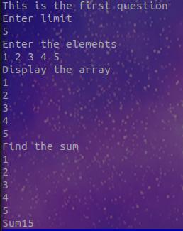

Practice Lab Assignment- II
Before the adding the method OddSum() to given code it is reading the size and inputs of the array and printing the inputs.
Snap of console :
a
void oddsum(){
int s=0;
for(int i=0;i<myList.length;i+=1) s+=myList[i]%2==1?myList[i]:0;
System.out.println("The odd sum of the array is:"+s);
}
public static void main(String[] args){
System.out.println("This is the second question:");
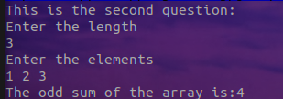
Scanner scan=new Scanner(System.in);
System.out.println("Enter the length");
int n=scan.nextInt();
q2 a=new q2(n);
a.oddsum();
}

Practice Lab Assignment- III

import java.util.Scanner;
class student {
int rollno;
String name;
int total_marks;
String grade;
student(int R, String S,int marks)
{
rollno=R;
name=S;
total_marks=marks;
}
void setData(int R,String S,int marks)
{
rollno=R;
name=S;
total_marks=marks;
}
void grading(student[] a){
for(student i:a){
if (i.total_marks>=90) i.grade="A+";
else if(i.total_marks>=80) i.grade="A";
else if(i.total_marks>=70) i.grade="B+";
else if(i.total_marks>=60) i.grade="B";
else i.grade="F";
}
}

void ShowData(student[] a)
{for(student i:a) System.out.println("Rollno:"+i.rollno+"\n"+"Name:"+i.name+"\n"+"Total marks"+i.total_marks+"\n"+"Maximum Marks:100"+"\n"+"Grade:"+i.grade);}
}
public class q3{
public static void main(String[] args){
Scanner scan=new Scanner(System.in);
student[] a=new student[3];
System.out.println("This is the 3rd question:");
for(int i=0;i<3;i++){
System.out.println("Enter the roll no:");
int rollno=scan.nextInt();
System.out.println("Enter the name:");
String name=scan.next();
System.out.println("Enter the total marks(max:100):");
int marks=scan.nextInt();
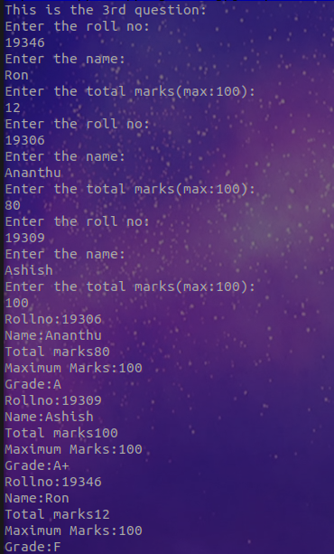
a[i]=new student(rollno,name,marks);
}
a[0].sort(a);
a[0].grading(a);
a[0].ShowData(a);
}
}

Practice Lab Assignment-IV
a)
Observation:
The following code takes in an integer 2D array whose length of row ,length of column and elements are taken from the user which is then displayed on the screen using a nested for loop where i represents the ith row and the j represents the jth column and the corresponding element is intArray[i][j]
b)
void SumofAntiDiagonal(){
int y=intArray[0].length-1,s=0;
for(int i=0;i<intArray.length;i++) s+=intArray[i][y-i];
System.out.println("The sum of the antidiagonal elements:"+" "+s);
}

